**PROGRAMMING AND ALGORYTHM**

**ASSIGNMENT**

**SUBMITTED BY: NARENDRA MAHARJAN**

1. **WAP to print the maximum number between two numbers:**

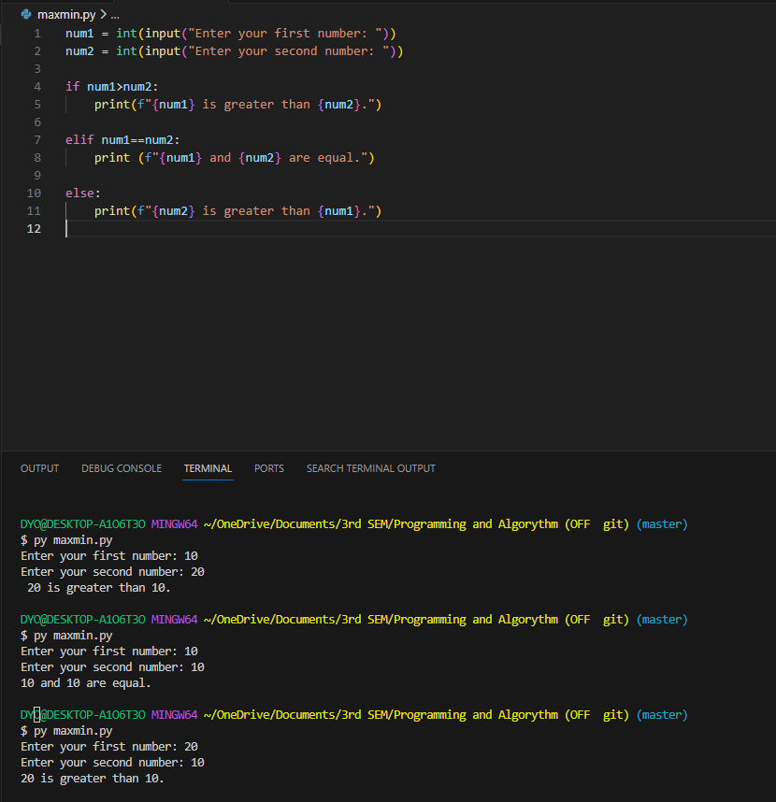

1. **WAP to print the minimum number between two numbers.**

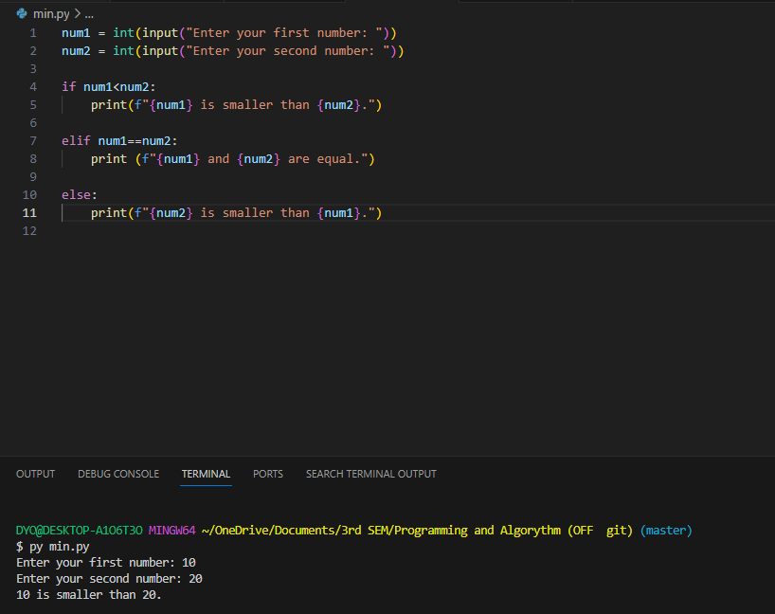

1. **WAP to print the largest among three numbers.**

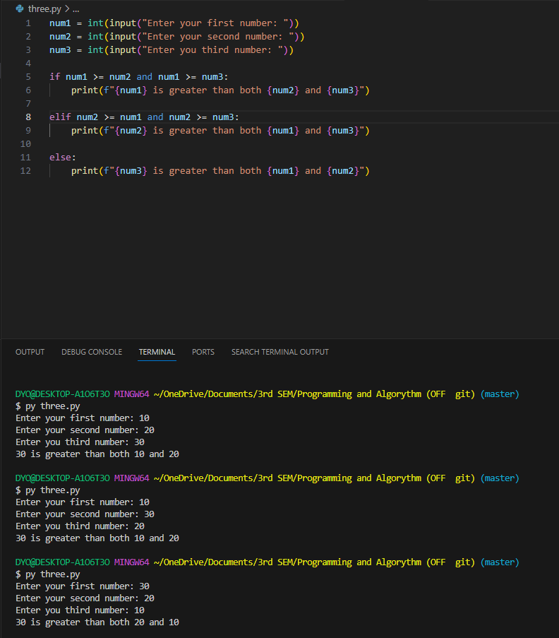

1. **WAP to print the smallest amount three numbers.**

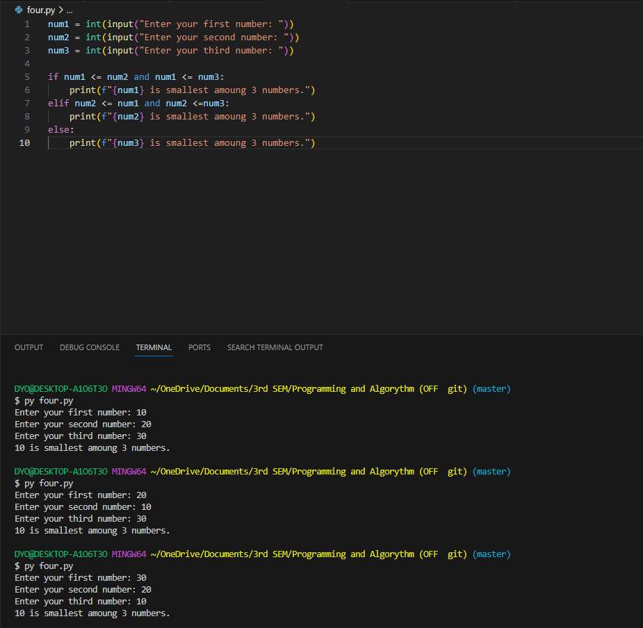

1. **WAP to check whether the entered number is even or odd.**

